

UniVerse

Final Report

*Sally Wang, Zijian Luo, Eric Feng, Steve Dou*

# 1. Project name & value proposition

Universe - College mentorship with freedom and ease

# 2. Team member names (use first name & last initial) and roles

* Sally Wang - UI/UX designer, web/app developer
* Steve Dou - web/app developer
* Zijian Luo - web/app developer
* Eric Feng - web/app developer

# 3. Problem/solution overview (2-4 sentences)

Our primary user is college counselors. The problem we are tackling is that counselors lack independence when choosing students they want to work with (and topics) as they often work under a centralized topic. A high-level overview of our solutions to allow counselors to choose to work with small groups of students with interests and backgrounds that cater to their own knowledge and expertise.

# 4. Needfinding

## a. Interviews: Who did you interview? How did you recruit & compensate participants? How did you interact with these participants? Etc.

* In our needfinding process, we interviewed six people:
  + A parent from China looking for college counselors for their kids. We recruited this participant through a high school parent WeChat group chat.
  + A private college counselor in Hong Kong. We recruited this participant from reaching out to random college counseling companies in Hong Kong.
  + An international student at Stanford from London. We recruited this participant from
  + A senior at UCSB from Cupertino. We found this participant from cold-approaching people in Downtown Cupertino.
  + A college-graduate who comes from a private high school in Florida. We recruited him from a friend of a housemate.
  + A Stanford student from Bolivia. We recruited her at an event held for international students on campus.
* We aimed to recruit a wide variety of people who have been involved in the college application process.
* We bought each in-person participant a Starbucks coffee drink. Each virtual participant was happy and willing to do the interview for free, so there was no compensation.
* We followed an interview arc, first asking for their background and involvement in their or someone else’s college application process. We would then hone in on specific questions and stories, pinpointing specific issues people faced.

## b. Synthesis: How did you synthesize? What did you learn?

We synthesized the feedback we collected by noting down as much of what our participants said and questioned throughout the interview. After that, we took all of the feedback and identified common pain points our interviewees

Overall, we learned that

* Applying to colleges in the US for international students can often come with many barriers - financial, information gap, etc.
* Some choose to not apply at all due to problems of cost, while others with the resources face their own struggles
* The college consulting industry is oversaturated in East Asia - and the quality of firms is questionable
* Even for domestic students, the quality of counselors is unreliable and the experience of receiving support is not personalized
* The tools counselors use to manage data/relationships can be improved

# 5. POVs & experience with prototypes

## a. Your final 1-3 POV statements :

POV 1 :

**We met a mother of a grade-10 student** who goes to an international school in Hong Kong. Because her elder child went through the same process a few years before and she plays an active role in her children’s education, she is very familiar with the college consulting landscape. **We were surprised to realize** despite recognizing that the Chinese international college application process has lots of flaws, in particular with the high fees of agencies, she is still keen on looking for a counselor for her younger child because “there is no other way” to succeed in the competitive landscape today**. We wonder if this means** she wants to seek support for her child through the college application process that has more reasonable fees but still offers non-generic, personalized advice. **It would be game-changing** to Give parents less exploitative college consulting packages while still making sure that the resources are of high quality for their children.

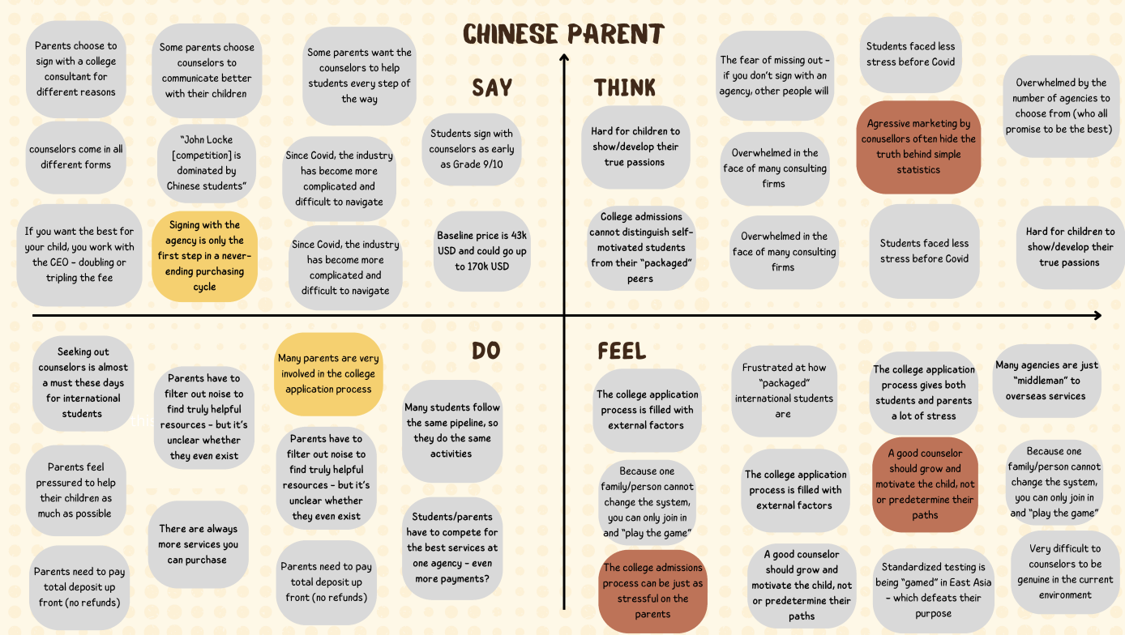

POV 2:

**We met Jonas, a college counselor with 8+ years of experience.** He has worked in Vietnam and mainland China before now works for a private college application consulting company in Hong Kong. **We were surprised that college consulting companies’ interests are tied to college rankings**. In other words, their pay is tied to the rankings of schools their students got into, even if the schools don’t match students’ personalities. **We wonder if this means** college counselors want to have more autonomy to help students with fewer outside factors**. It would be game-changing to** have a platform where college counselors can find students directly without private companies.

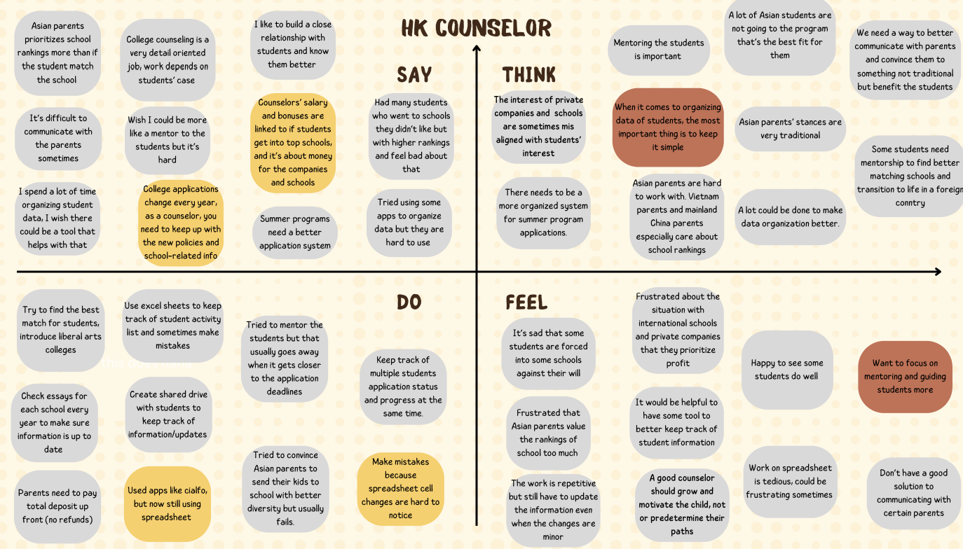

POV 3:  
  
**We met** Karim, a wealthy international student from a French school in London attending Stanford University, with two brothers who also attended Stanford. **We were surprised to notice** that Karim’s main struggle was appealing to what he thought American universities wanted, especially with his limited exposure to formal resources or advice. **We wonder if this means** Karim created a fabricated portrayal of himself to fit a certain cookie-cutter archetype of a student that he or his brothers believed was more likely to be accepted. **It would be game-changing to** help students navigate beyond superficial aspects of the college application process, convincing them that they need to convey themselves authentically without omitting their unique strengths and qualifications.

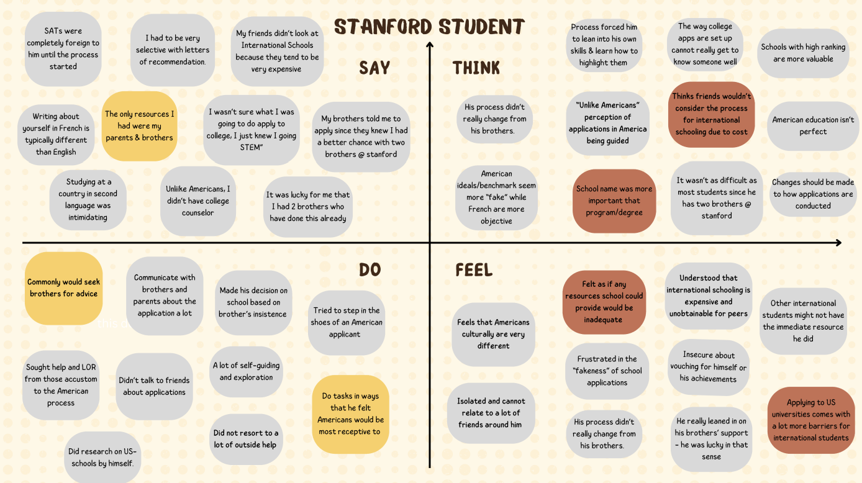

## b. A sampling of the HMWs that stemmed from each POV:

POV 1:

1. HMW: Make information surrounding college applications more transparent/accessible
2. HMW: Make information regarding college applications more accessible (price) and effective/high-quality
3. HMW: Guide parents in choosing a suitable counselor

POV 2:

1. HMW: connect college counselors directly with students
2. HMW: make students understand what they want better
3. HMW: extend the counseling process so it’s not just about getting into good schools

POV 3:

1. HMW: Help students delineate between useful advice and speculation that is not based on truth
2. HMW: Make the struggle of appealing to foreign audiences a fun learning experience
3. HMW: Have “archetypal” students be less appealing to college applications

## c. Top 3 solutions from brainstorming

1. Connecting students with college students via a marketplace to exchange information/advice
2. An open line of communication from college admissions/extracurricular programs to interested high school students
3. “Tinder” matching college counselors and high school students

## d. Brief description of each experience prototype:

### Experience Prototype 1:

**i. The assumption being tested**

Students care about programs specific to their interest, but are not really knowledgeable about them.

**ii. Key aspects of the prototype setup**

* Understand the goal: to rank the importance of different factors (e.g., academics, campus life, financial aid) in choosing a college and evaluate how accessible information about these factors was during their decision-making process.
* Recruit participants who applied to multiple universities and chose Stanford, leveraging mutual connections or relevant social groups.
* Prepare Post-it notes with common decision-making factors (e.g., reputation, financial aid, proximity to home).
* Have blank Post-its for participants to add unique factors they considered.
* Provide a two-axis board: one for ranking importance and another for ease of finding information.
* Ask participants to arrange the Post-its on the board based on how important each factor was and how easily they found information about it.
* Facilitate discussions about why they ranked factors as they did and how information availability influenced their choices.
* Take photos of each board for later analysis.
* Record qualitative insights from discussions about their decision-making process.
* Identify patterns across participants to understand which factors were universally important or consistently easy/difficult to find information on.

**iii. What worked/didn't work, implications**

* What worked:
  + Student expressed they did consider academic programs.
  + Students were engaged and personally reflected on what they valued.
* What didn’t work:
  + For smaller schools, it was harder to find information on how their programs are different/unique.
  + Student expressed it was harder to find information about programs at smaller colleges, but they did not consider this to be a big problem.
  + They ranked it based on what they thought colleges wanted.
* Implications:
  + This direction is NOT the most suitable, seeing a notable number of international students overweigh college brand name.
  + Information accessibility of smaller schools/programs is not something they are concerned with.
  + The assumption was NOT applicable.

### Experience Prototype 2:

**i. The assumption being tested**

Students care about college counselors’ personalities, personal interests, and values beyond just their academic qualifications.

**ii. Key aspects of the prototype setup**

* Determine the goal: to understand what factors influence students’ preferences when selecting a college counselor and the rationale behind their choices.
* Recruit Stanford students who previously used private counseling services, leveraging friend networks or personal connections.
* Develop 15 diverse counselor profiles that include details such as counseling style, areas of expertise (e.g., financial aid, essay editing), personality traits, and success rates.
* Ensure profiles are realistic and representative of actual counselor characteristics.
* Present the profiles to participants and ask them to choose the counselor they would most likely work with.
* Facilitate individual or group sessions where participants share their reasoning behind their choice.
* Record which counselor each participant chooses.
* Collect qualitative feedback through follow-up questions, focusing on attributes they prioritized (e.g., expertise, communication style).
* Identify patterns in the selection criteria (e.g., trustworthiness, affordability).
* Categorize insights into actionable themes, such as counselor traits that resonate most with students or gaps in perceived value.

**iii. What worked/didn't work, implications**

* What worked:
  + Very fun and engaging for participants.
  + They clearly enjoyed choosing counselors that matched them more closely, and there was usually a clear option for the students to pick.
* What didn’t work:
  + We could’ve created better profiles with broader information and backgrounds that spoke to more students.
* Implications:
  + The solution is extremely suitable.
  + Students work better with counselors that match themselves.
  + The assumption is applicable: students do value more than just counselors’ academic qualifications and past results.

### Experience Prototype 3:

**i. The assumption being tested**

College students are willing to share college advice and need non-college advice from others.

**ii. Key aspects of the prototype setup**

* Identify the goal: to explore how students perceive and interact with a peer-to-peer exchange for CS homework help, focusing on usability, effectiveness, and preferences.
* Recruit Stanford students, particularly those with experience in HCI or CS homework challenges, through friends or academic networks.
* Set up a simple, simulated homework help exchange platform or workflow where participants can offer or request help.
* Include basic interaction points like task posting, response mechanisms, and feedback options.
* Design an HCI interview guide focusing on:
  + Usability of the exchange (e.g., ease of finding help).
  + Perceptions of fairness and reciprocity.
  + Motivations for participating in the exchange (e.g., building skills, social benefits).
* Facilitate an interactive session where participants use the exchange to ask for or provide CS homework help.
* Conduct one-on-one HCI interviews immediately after the interaction to capture feedback on their experience and decision-making process.
* Record interview responses, focusing on pain points, preferred features, and barriers to participation.
* Analyze patterns in student motivations and behaviors.
* Categorize insights into themes, such as interface design preferences, peer interactions, or perceived value of the exchange.
* Identify opportunities to improve the exchange platform or process based on participant feedback.

**iii. What worked/didn't work, implications**

* What worked:
  + He understood the premise very quickly.
  + He liked knowing how much commitment he was getting himself into before.
* What didn’t work:
  + Complained about the overhead of getting help requiring multiple back and forth.
  + Misused the experiment for attempted academic dishonesty (jokingly).
  + Didn’t like the possibility of only partial help or advice, depending on what I accepted.
  + Felt transactional.
* Implications:
  + People can easily lie to get the information they want.
  + This solution is NOT the most applicable.
  + The assumption IS true, but students may find shortcuts like lying.

# 6. Design Evolution

## a. Final Solution

### i. Description:

The final design of the application, UniVerse, focuses on providing college counselors the ability to select students based on shared interests and backgrounds, interact with them using AI-powered tools, and monitor their progress in an intuitive and efficient manner. The app addresses the problem of centralized topic-based workflows that limit counselors' independence. It introduces features such as personalized groupings, actionable AI insights, and a messaging interface to build long-term relationships with students.

### ii. Rationale for the Selected Solution:

From our need-finding process, we realized that a large pain point for college counselors, especially those located internationally, is being unmet: they lack freedom when choosing the students and topics they want to work with. Although the college counseling industry is very mature, there has yet to be a real effort to help improve the teaching experience from the counselor’s point of view. Therefore, we chose the “finding students” aspect to be our simple task, and our medium and complex tasks also responded to other unmet needs of counselors, such as the need to organize data more effectively and incorporate the use of AI in their work (to replace the “busy” elements of their work). Our solution was further confirmed through later rounds of evaluations, such as our low-fi usability testing.

## b. Tasks

### i / ii. Task description and their importance to the user base

1. **Simple Task:** Enable counselors to find students they want to work with.
   * Importance: Fundamental to providing autonomy and matching counselors' expertise with student needs.
2. **Medium Task:** Facilitate teaching sessions within the app environment.
   * Importance: Key to creating an efficient workflow for counselors to manage and teach students.
3. **Complex Task:** Provide AI-powered tools to generate actionable insights on student progress.
   * Importance: Crucial for offering a differentiated value proposition by leveraging technology for personalized recommendations.

### iii. Annotated task flows using images of the final interface

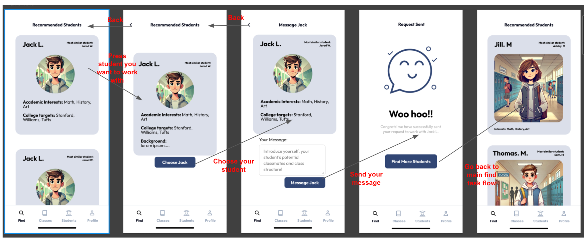

Simple task: Starting with a feed of recommended students for the counselors, a counselor can choose a student to read more about the student, then if the student seems like a good match, they can send a personalized message to pitch themselves. After sending the message they will wait for a response, and find additional students while they wait for a response.

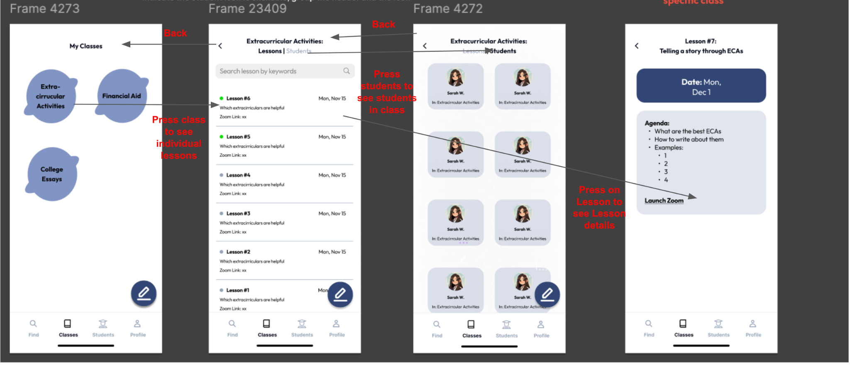

Medium task: A counselor can make classes to teach students, each class will have specific lessons that have been taught or will be taught to a list of students. Each lesson will have an agenda, a date, and a link to a zoom meeting that the lesson will be hosted on.

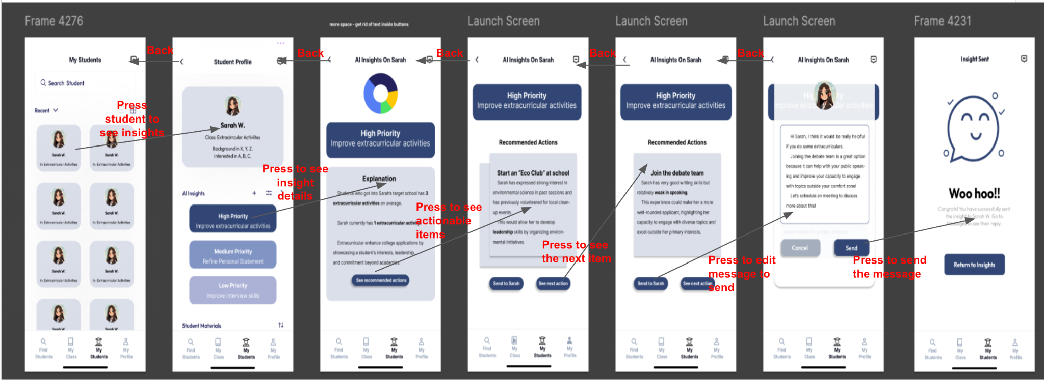

Complex task: A counselor can look at what students have agreed to work with them. Each student will have automatically created AI suggestions for how they can personally improve. A counselor can click into the recommendations, see why it is recommended and send a personalized suggestion directly to the student to make these changes.

## c. Design Evolution Visualization(s) and Rationale

### Initial LoFi implementation:

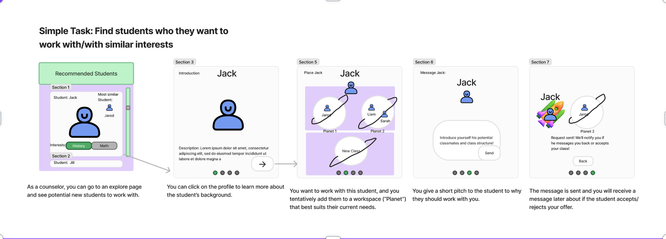

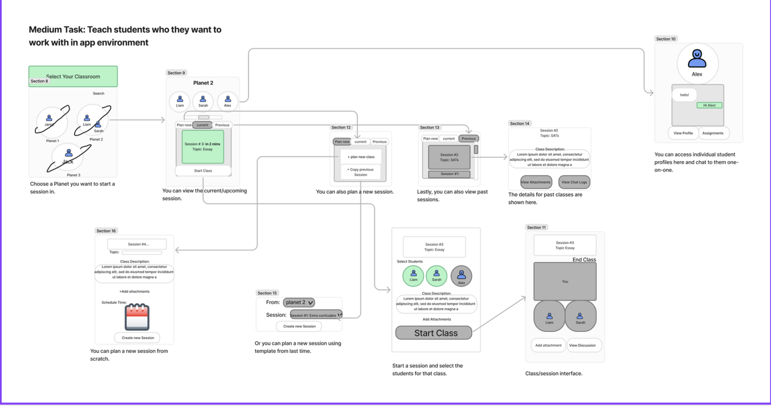

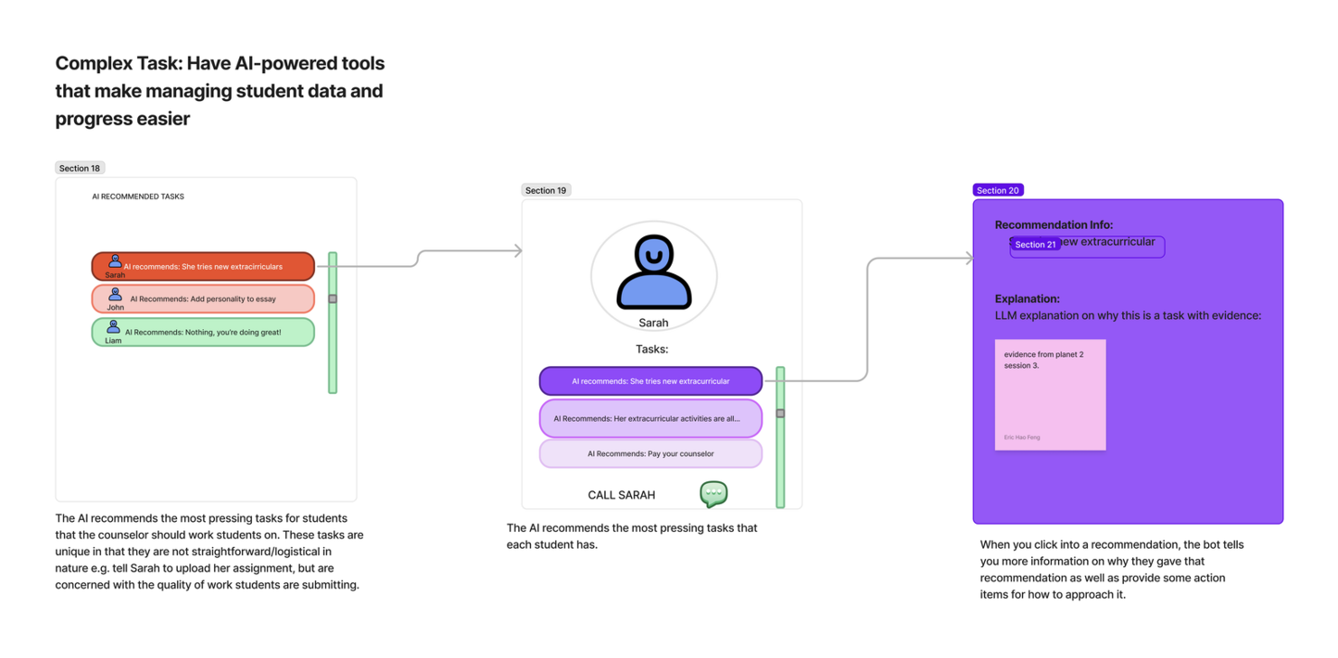

Above are the initial designs of our tasks in our initial prototyping. After this initial prototyping, we created a paper prototype to test how users interacted with this design. Below is an example of our usability testing metrics of this design.

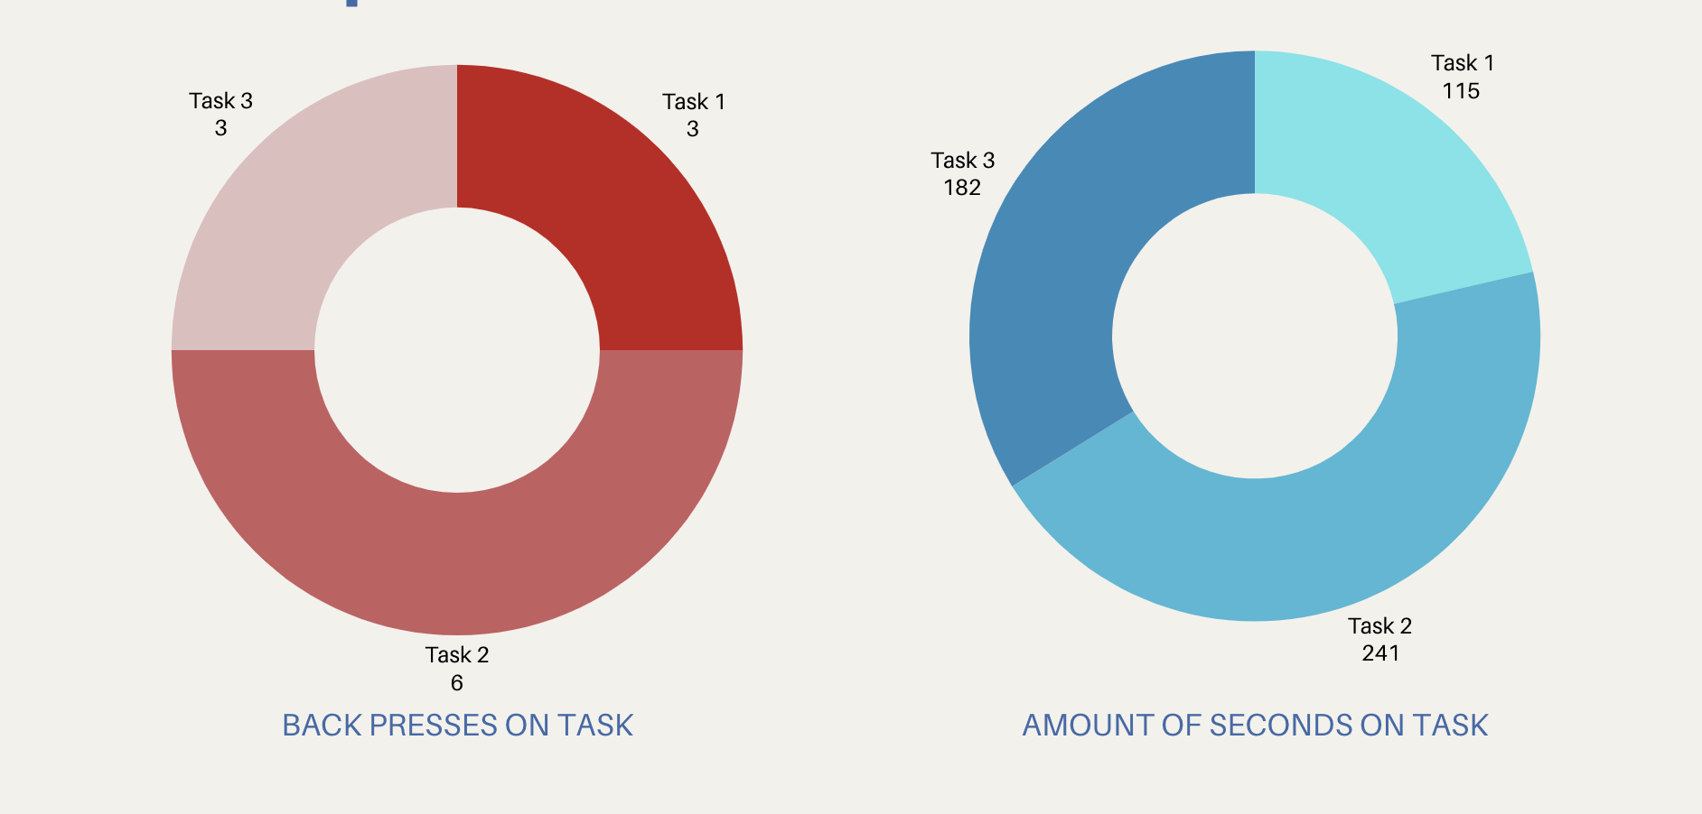

The above metrics are used to measure our designs. Two metrics were how long a user would spend on a single task flow and how many times the user would need the back button to complete the task flow. We believed that a user taking a longer time to finish a task flow meant that the design was inefficient or unintuitive, and pressing back buttons means that some of our tasks flows could not be assumed without providing explanation or changing the logical flow. After the testing, we had insights on which tasks were too complex, which buttons and functionalities were unitinutive, and changes that could be made to make the design overall more easier to use.

### Medium fidelity prototype:

Below were the changes we implemented from the initial lofi prototype to our mid-fi prototype. Major changes included changing logic in simple tasks such that students are not automatically assigned to classes. Making the recommended AI insights actual actionable items that were more intuitive to users. Lastly major revisions were made to the medium task to simplify the view.   
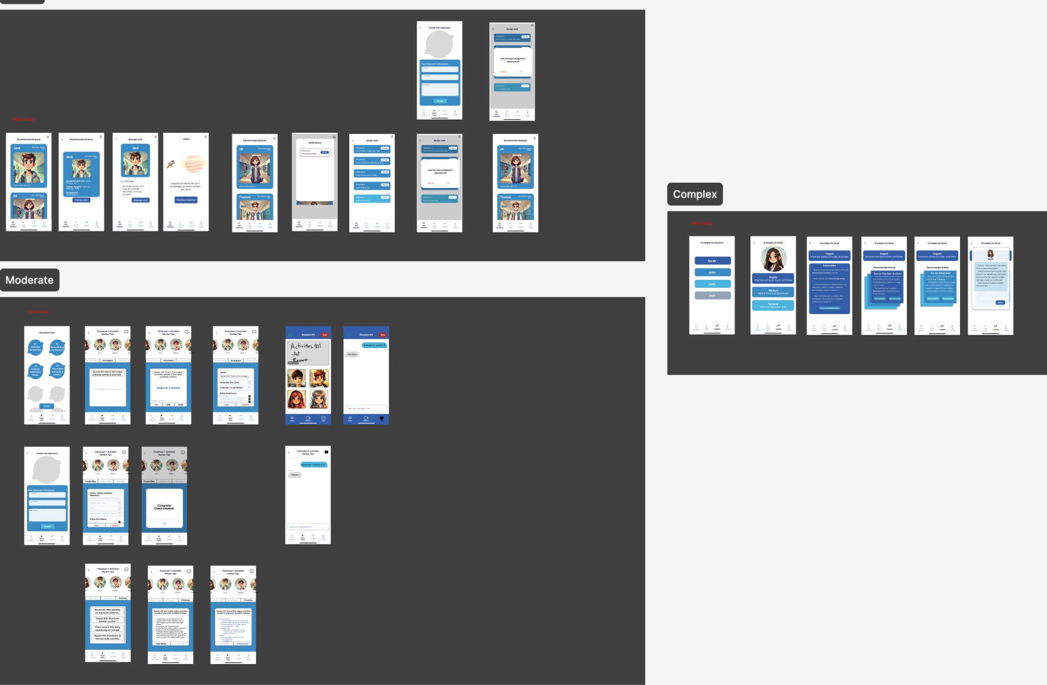

After the Medium Fidelity Prototyping, we had a team of four members do a heuristic evaluation of our app. A major issue we saw in the evaluation is issues with consistency and standards, intuitive naming of our components and tasks, and complaints of cluttered designs that were not minimalistic.

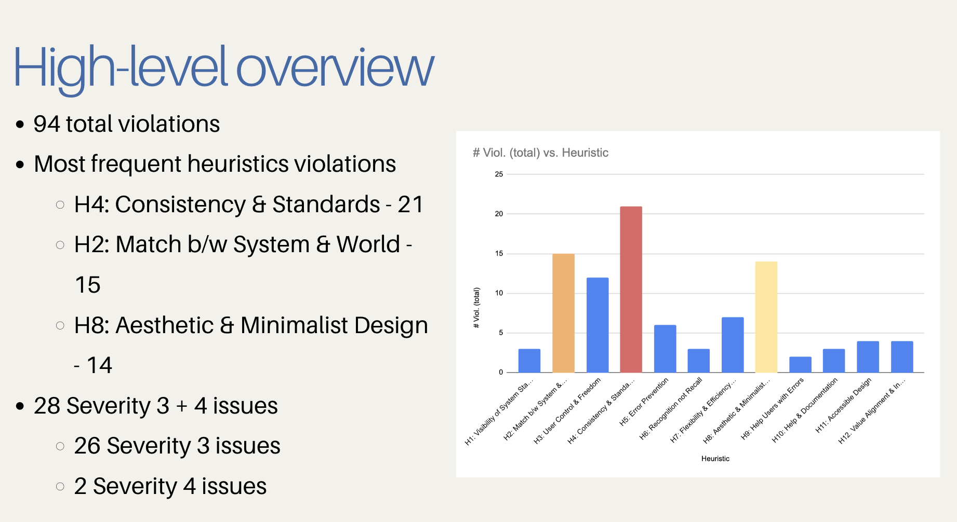

Some patterns of heuristic violations we discovered were:

* The UI is not aesthetically matching for an education app
* Terminology is inconsistent across tasks and was not abundantly clear to users what they meant, e.g. classes vs. sessions
* Some screens are too cluttered, making navigation difficult
* Navigation bar titles do not match with page headings

Some examples of HE severity violations and changes with rationale: (including all 28 sev 3s and sev 4s would be difficult to fit, to see a longer list of sev 3s and 4s with changes, view our [A8 presentation appendix](https://www.canva.com/design/DAGWxWMJFS0/QqSeTK8es5B9VcnUdqL2fA/edit?utm_content=DAGWxWMJFS0&utm_campaign=designshare&utm_medium=link2&utm_source=sharebutton))

#### 

#### Severity 4 Violations

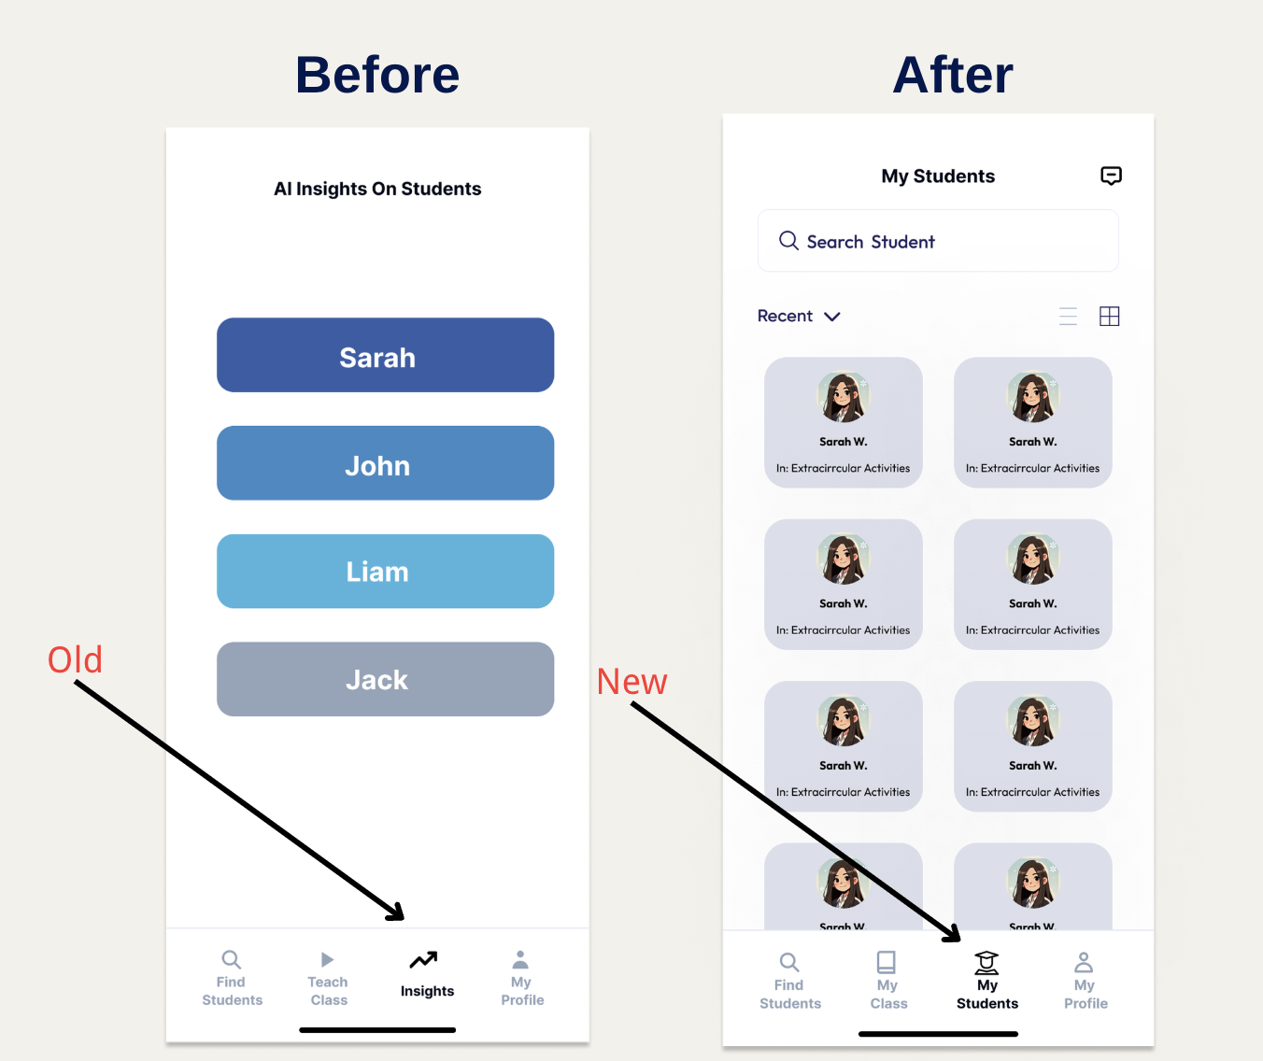

**H3 - No way to engage with students beyond insights**

**Rationale:** Students need to receive guidance from counselors in more ways than just the “Insights” functionality.

**Fix:** Change naming of tab from “Insights” to “My Students”. The “Insights” name makes the functionality of the tab too narrow as counselors are limited to viewing/sending insights to students.

**Progress towards usability goals:** This is more intuitive as counselors should be able to interact with students in various ways, and not just limited to just AI insights.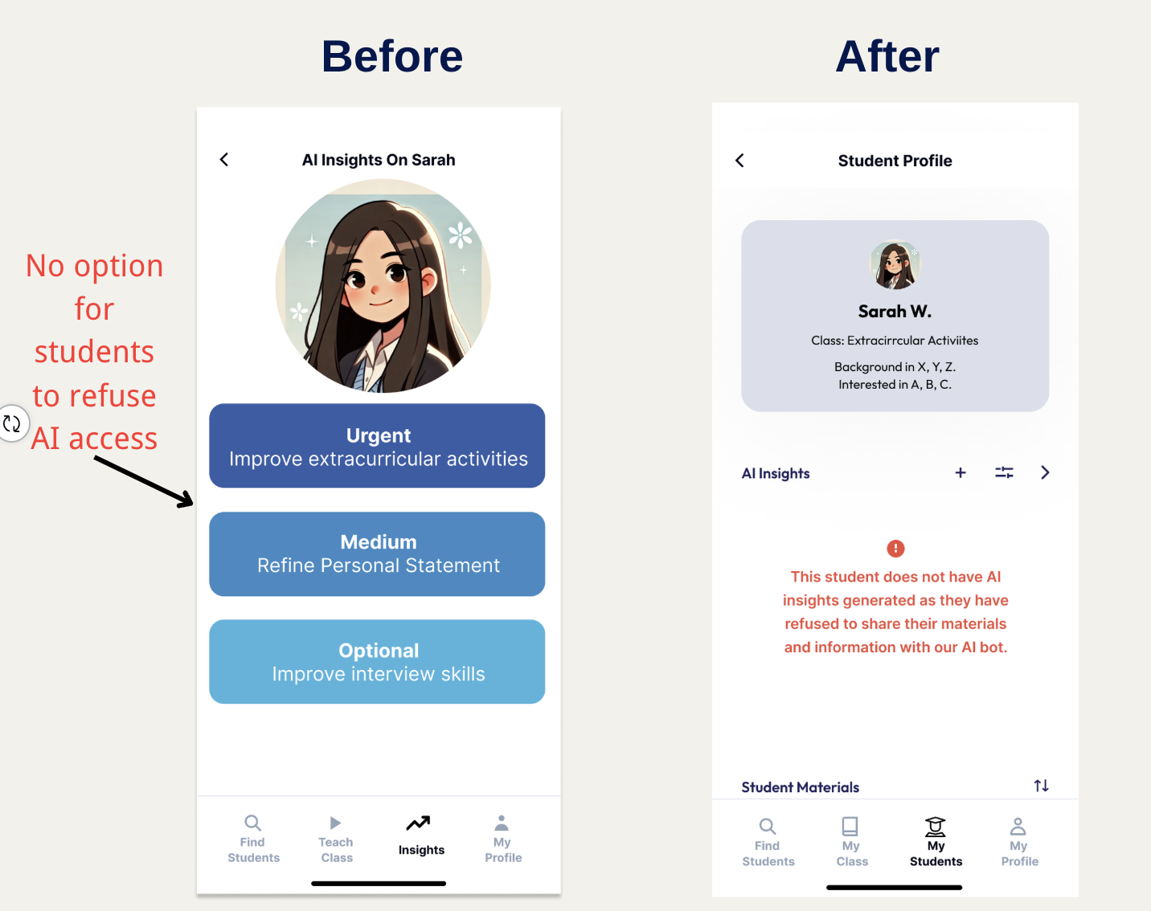

**H12 - Some students might not consent the AI to access their information**

**Rationale**: Did not take into account that some students can refuse allowing AI access to their information, which means there won’t be any AI insights generated.

**Fix:** Give students the choice to refuse access on their end (not implemented in our counselor-focused interface). When the counselor clicks on a student who did not consent to AI use, show an error messages explaining this.

**Progress towards usability goals:** Counselors are updated quickly on the absence of AI insights, and the clear error messages tell them the reason behind the absence - which improves intuitiveness. It also generally makes the app more inclusive.

#### Severity 3 Violations

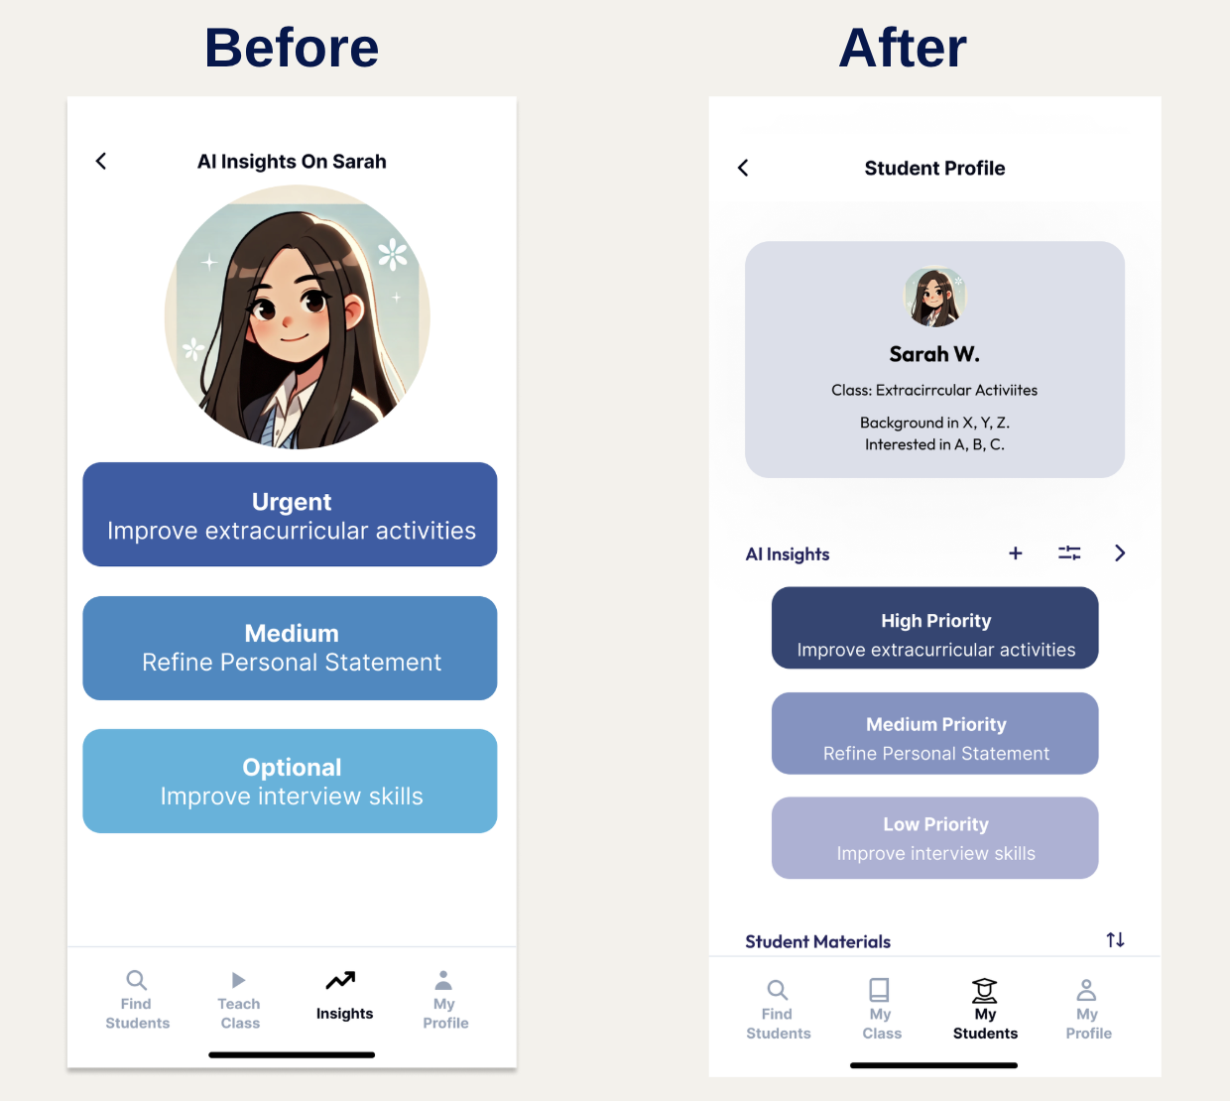

**H2 - Within each student's AI insights, the descriptions of "Urgent", "Medium", and "Optional" are unclear.**

**Rationale:** The urgency of tasks should be communicated differently and consistently. Just saying “Urgent” can cause confusion.

**Fix:** Change the labels to "High priority", "Medium priority", and "low priority” to explicitly let users know the ratings have to do with priority.

**Progress towards usability goals:** Improves intuitiveness as users no longer have to guess what “high,” “medium,” etc. are in regards to.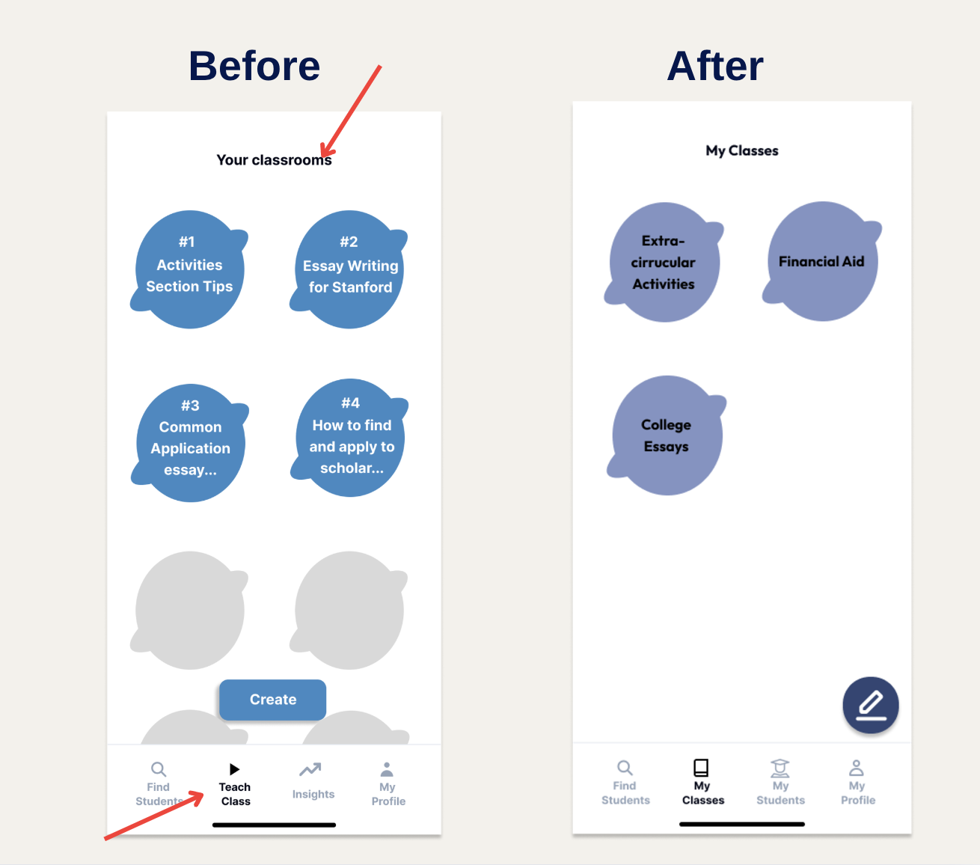

H4 - Unclear if there is a difference between class and classrooms

**Rationale**: The navbar name does not match the page heading. For instance, On the "Teach Class" page, it says "Your Classrooms". Inconsistent terms might signal to users that they mean different things.

**Fix:** Have terminology consistent, especially if it is a recurring concept throughout the app.

**Progress towards usability goals:** Improves efficiency as users will not be confused about where they are in the navigation progress as the feedback they get matches their expectations.

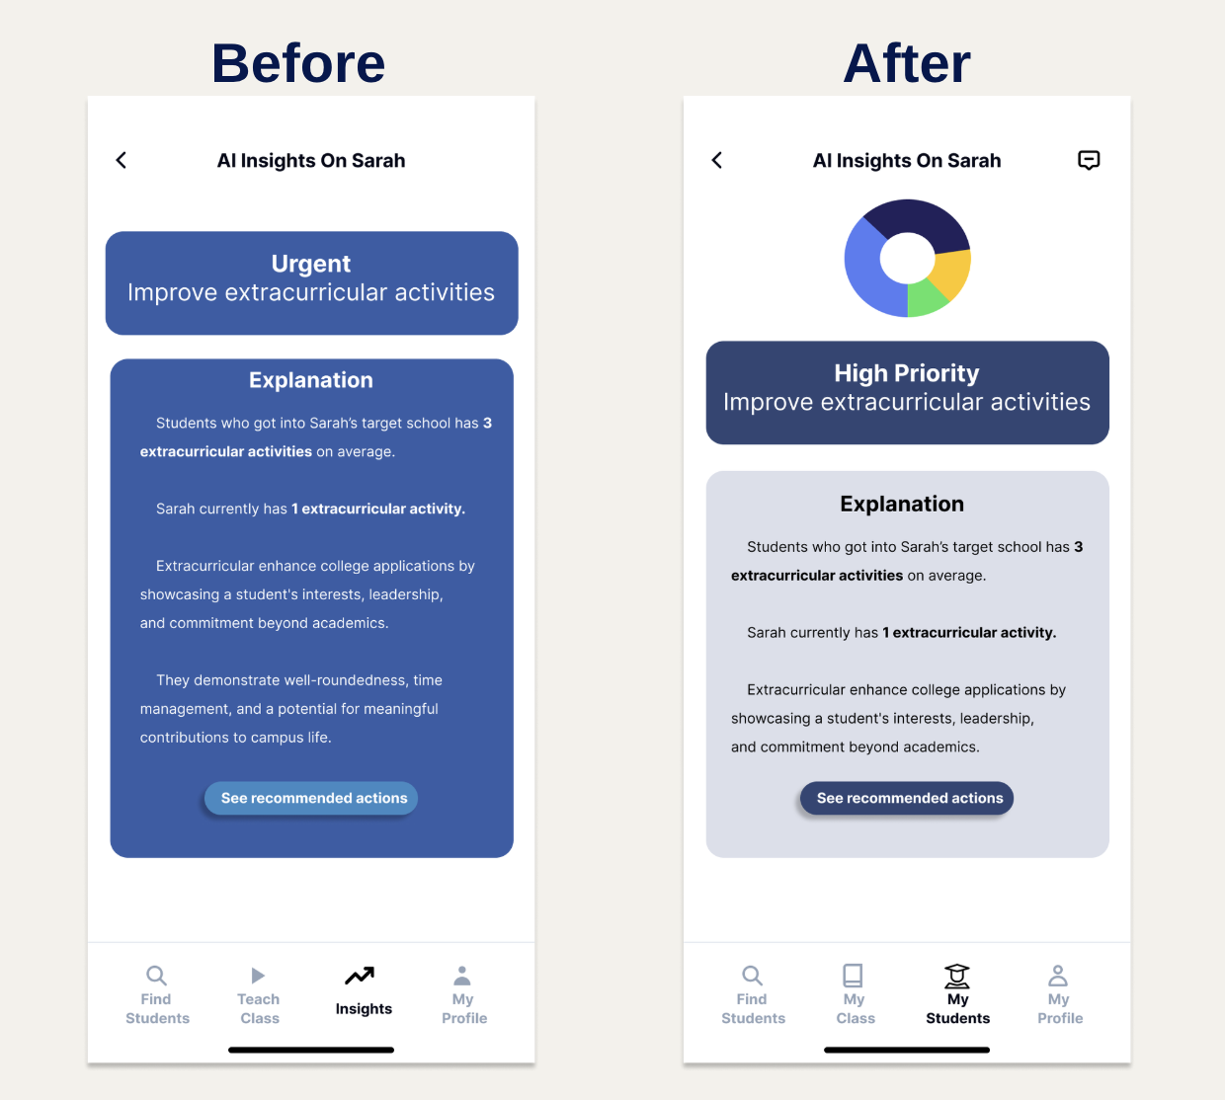

**H8 - Insights page is too text-heavy**

**Rationale:** The insights page is too filled with text, and both sections sharing the same background color makes it hard to differentiate them.

**Fix:** Break up text more with some images/data to support the insight visually, and use different colors to separate the insight with the explanation.

**Progress towards usability goals:** Improves intuitiveness as the contrast in colors (e.g. the navy of the first section) guides the user first read the insight section, then look at the explanation section, which is the logical flow.

**H8 - Clean and spacious design is better**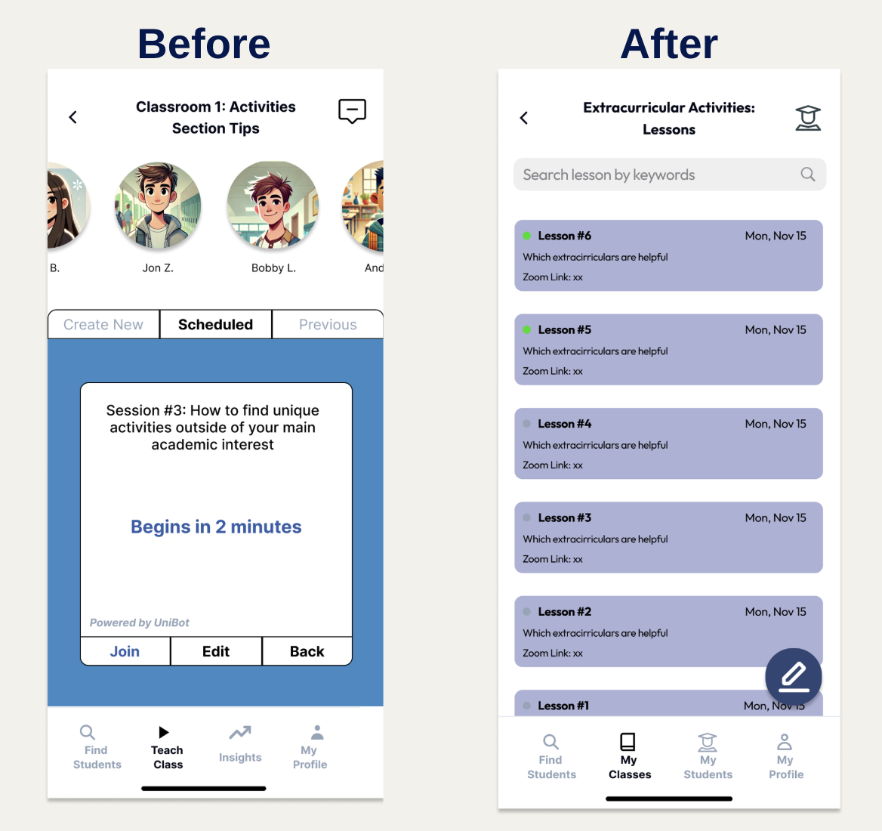

**Rationale:** The layout of the medium task screen is too complicated, with too many options presented to the user at once.

**Fix:** Make sessions a list format where the most recent sessions are at the top and the least recent sessions are at the bottom.

**Progress towards usability goals:** Improves efficiency as users do not have to navigate to different tabs to see past/upcoming sessions. This can be achieved by scrolling, and the search bar makes finding a specific session even easier.

### High fidelity prototype:

Taking the Heuristic Evaluation feedback, we designed our final Hi-Fi prototype. Major changes included a major rework of the medium task to make it much more simple, changes in aesthetics including fonts and colors, and many changes in labeling to make task flows seem more intuitive. 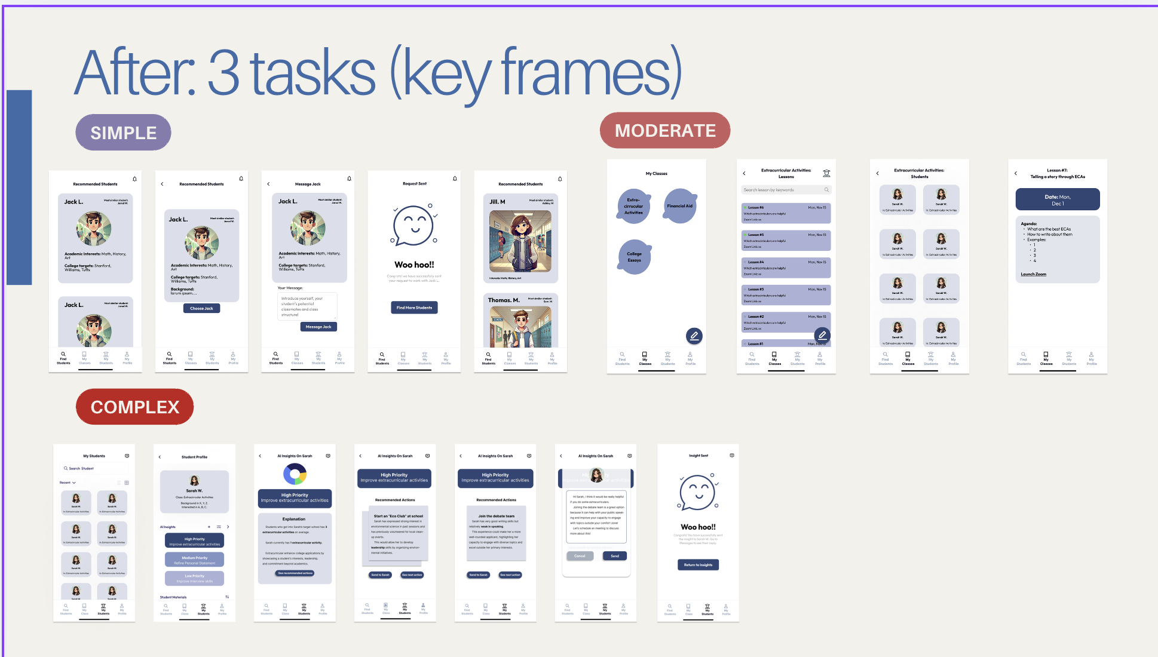

## d. Values in Design

### i. Identified Values:

1. **Freedom:** Enabling counselors to have autonomy over their work by allowing them to choose students, tailor sessions, and manage tasks independently.
2. **Ease:** Simplifying workflows and reducing cognitive load, ensuring counselors can perform their tasks quickly and efficiently.
3. **Community:** Fostering a sense of collaboration and long-term relationships between counselors and students through communication features and group-based learning.

### ii. Embedding Values in Design Features:

* **Freedom:**
  + Tabs like “My Classes” allow counselors to manage sessions, students, and lessons independently.
  + The "Find Students" feature helps counselors select students based on shared interests and backgrounds, aligning with their expertise.
* **Ease:**
  + Simplified session workflows, such as replacing text-heavy sections with visuals and consolidating information into scrollable lists, reduce complexity.
  + The redesign of the teaching tab icon to a textbook and consistent terminology (e.g., “Lesson 1,” “Lesson 2”) ensures a more intuitive user experience.
* **Community:**
  + The messaging interface allows counselors to engage with students directly, building relationships beyond AI insights.
  + AI-powered recommendations and actionable insights provide counselors with meaningful ways to guide students, reinforcing the collaborative nature of the app.

### iii. Value Tensions:

1. **Freedom vs. Ease:**
   * Providing autonomy for counselors, such as customizing classes and selecting students, sometimes introduced complexity, like managing numerous features. Streamlining these functionalities required careful design trade-offs.
2. **Freedom vs. Community:**
   * Allowing counselors to choose students freely raised concerns about potential biases when using profile pictures. This was mitigated by allowing students to use avatars instead of real images.
3. **Ease vs. Community:**
   * Introducing new communication features like direct messaging added additional UI elements. While this supported the value of community, it slightly increased the complexity of the interface.

### iv. Addressing Value Tensions:

* Freedom and ease were balanced by simplifying redundant inputs (e.g., removing unnecessary description fields for new classes) and unifying terms to reduce confusion.
* Community features, such as messaging and actionable insights, were designed to integrate seamlessly into existing workflows to minimize additional complexity.

# 7. Final prototype implementation

## a. Tools used; pros and cons of these tools:

**1. React Native (Frontend Framework)**

* **Pros:**
  + Cross-Platform Development: Write a single codebase for web, iOS, and Android, saving development time and effort.
  + Flexibility: React Native is non-opinionated, allowing developers to structure applications as needed without rigid conventions.
  + Active Community and Libraries: Extensive community support and libraries make it easy to find solutions and implement features.
* **Cons:**
  + Steeper Learning Curve: The flexibility in structuring code can lead to inconsistencies across pages and requires disciplined development practices.
  + Performance Limitations: For complex UI interactions, React Native may not perform as well as fully native frameworks.

**2. Expo (React Native Development Toolchain)**

* **Pros:**
  + Ease of Setup: Simplifies the setup and deployment of React Native apps with built-in tools and configurations.
  + Testing and Debugging: Provides a seamless testing environment with the Expo Go app, allowing real-time testing on devices.
* **Cons:**
  + Limited Native Module Support: Some advanced features requiring custom native modules are harder to integrate, potentially necessitating an "eject" from Expo.
  + Dependency on Expo Ecosystem: Locking into Expo can limit flexibility for customizations outside its supported features.

**3. Figma (UI/UX Design Tool)**

* **Pros:**
  + Collaborative Design: Enables real-time collaboration among team members for wireframing and prototyping.
  + Ease of Use: Intuitive interface with tools for designing, prototyping, and iterating on UI/UX.
  + Reusable Components: Makes it easy to create and test different design iterations efficiently.
* **Cons:**
  + Limited Interaction Simulations: While great for prototyping, it lacks support for simulating advanced interactions or transitions compared to coding prototypes.
  + Export Challenges: Moving from Figma designs to React Native code can require additional tools or manual work.

**4. Supabase (Backend Solution - Planned)**

* **Pros:**
  + Pre-Built Backend Features: Offers authentication, database, and real-time APIs that simplify backend development.
  + PostgreSQL Integration: Makes data handling and queries efficient and scalable.
  + Developer-Friendly: Provides a robust and easy-to-use interface for managing backend services.
* **Cons:**
  + Learning Curve: Requires some time to fully understand and integrate with React Native.
  + Early Adoption Risks: As a relatively new tool, certain features may lack the maturity of older backend solutions.

## b. Wizard of Oz techniques used:

1. AI Simulation:
   1. The AI-powered insights and recommendations were presented as if generated dynamically, but they were pre-defined, making it appear that an AI system was operational.
2. First-Time User Setup:
   1. The app simulated a first-time user experience by providing pre-existing student data and profiles to demonstrate the functionality counselors would encounter.
3. Interactions Without Full Backend Logic:
   1. Features like sending messages or tracking actionable steps appeared functional, but the underlying backend processing was not fully implemented, relying on pre-determined responses.

## c. Hard-coded techniques used:

1. Student Profiles:
   1. Pre-created profiles with names, backgrounds, and interests were hard-coded into the app to simulate a realistic starting database.
2. AI Insights and Recommendations:
   1. All "AI" insights and suggested actions were manually written and embedded as static content, rather than being dynamically generated.
3. Login/Sign-Up Flow:
   1. User input for the login/sign-up process was hard-coded, bypassing actual logic to allow immediate access to the app's main features.
4. Session Content:
   1. Class/session data, including descriptions and lesson structures, was pre-populated to mimic app functionality without real-time data input.

8. Reflection & next steps

## a. What were your main learnings from this quarter about the design thinking process, your studio theme, and your own project?

**1. About the Design Thinking Process**

* Empathy-Driven Design:
  + Instead of having a preconceived notion about what “solution” we wanted to create, going out into the community and interviewing people, in particular including people from diverse grounds, helped us focus on discovering the pain points of needs of counselors in the college application space.
* Iterative Improvement:
  + We learned the importance of continuous feedback to refine our designs. For example:
    - Early prototypes lacked inclusivity, as they didn’t account for students opting out of AI features. Feedback led us to include clear error messages to address this gap.
    - Overly complex navigation patterns were simplified by unifying terminology (e.g., "classes" vs. "sessions").
* Testing for Usability:
  + Heuristic evaluations exposed issues, like text-heavy screens and unclear iconography. Iterative design resolved these problems by adding visuals, improving icons (e.g., textbook icon for teaching), and using color for better flow.

**2. About the Studio Theme: Designing for Job Accessibility & Career Development**

* Barriers to Job Accessibility:
  + Many systemic challenges in career development, such as lack of independence or inclusive tools, were reflected in counselors’ workflows. Our app addressed these by providing features like:
    - Freedom to create tailored classes and groups.
    - Messaging tools to build long-term relationships and foster trust.
* Making Processes Less Daunting:
  + Counselors’ tasks, like selecting students and managing sessions, were streamlined. For instance, replacing text-heavy screens with visuals reduced the cognitive load, making their work easier and more efficient.
  + Simplified workflows for adding or modifying classes allowed counselors to focus on career development tasks without being bogged down by technical hurdles.
* Inclusivity and AI:
  + By introducing AI-powered tools, we aimed to enhance the accessibility of insights. However, we ensured inclusivity by allowing students to opt out of AI data usage and notifying counselors with clear explanations when insights were unavailable.

**3. About Our Project**

* Empowering Counselors:
  + Freedom and autonomy were central. Features like the “Find Students” tab empowered counselors to choose students aligned with their expertise and interests, improving their ability to guide students effectively.
* Efficiency and Usability:
  + Usability goals, like reducing task time and back-button usage, shaped our design. For example:
    - The session list was redesigned for scrolling, allowing counselors to find information faster.
    - Removing redundant input fields, like class descriptions, sped up workflows and made the app easier to use.
* Building Community:
  + Messaging features allowed counselors to connect with students directly, fostering stronger relationships. These connections were critical for long-term career development.

Overall, this quarter provided a deep understanding of empathy-driven design and how iterative processes can address real-world challenges in job accessibility and career development. By creating an app that aligns with counselors’ needs and values, we addressed barriers to job readiness and made career guidance more accessible, impactful, and inclusive. The project demonstrated how thoughtful design can empower users to navigate systemic challenges and build stronger career pathways.

## 

## b. If you had more time, what might you add in the future?

#### **1. Creating the Student Side**

* Student Profiles: Allow students to create profiles with goals and interests to improve matching with counselors.
* Two-Way Communication: Enable students to respond to counselor insights, fostering stronger relationships.
* Evaluation Connection: Addresses H12 (Value Alignment) by enhancing collaboration and community.

#### **2. Expanding Wizard of Oz Techniques**

* Dynamic AI Simulations: Simulate real-time AI-generated insights to better test user expectations.
* Student Consent Simulation: Test how opt-in/opt-out workflows impact counselor efficiency and user trust.
* Evaluation Connection: Resolves H2 (Match Between System and Real-World) by simulating realistic app interactions.

#### **3. Building and Hosting a Backend**

* Dynamic Data Management: Replace hard-coded elements with real-time student and session data updates.
* Secure Authentication: Add privacy features to handle student opt-outs more effectively.
* Evaluation Connection: Solves H4 (Consistency) and H8 (Efficiency) by ensuring seamless data updates and faster workflows.

#### **4. Hosting on a Scalable Platform**

* Real-Time Updates: Allow instant syncing of data and user actions across devices.
* Data Analytics: Gather usage metrics to refine the app based on real-world patterns.
* Evaluation Connection: Improves H8 (Efficiency) by reducing delays and redundant actions.